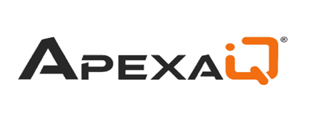

Research Report

Made By:

Name: Soham M. Patil
Class: 3R (Computer Science & Engineering)

- What does Apexa iQ do and what problem does it solve?
Ans: Apexa iQ is a platform that helps organizations keep track of their IT assets and improve their cybersecurity. It automatically finds devices, software, cloud resources, and other technology connected to a company’s environment. A common problem in companies is that IT teams do not always know exactly what devices or software are being used. Some devices may be forgotten, software licenses may expire, warranties may be missed, and security updates may not be installed. These gaps can increase the chance of cyberattacks and system failures. Apexa iQ continuously collects information about the company’s technology and presents its overall IT and security condition in a simple score. This helps IT teams identify the most important problems first and take action before they cause serious security incidents, unnecessary expenses, or downtime.
- What is IT Asset Management (ITAM) and why do we need it?
IT Asset Management (ITAM) is basically keeping a master list of all the tech a company uses. This means tracking physical items like laptops, desktops, and servers, as well as digital things like software subscriptions and cloud accounts.We need ITAM because if a business doesn't know what tech it actually has, it ends up wasting money and creating security risks. For example, without it, a company might keep paying monthly fees for software that nobody uses anymore, or they might leave an old, forgotten computer connected to their network without security updates. That outdated computer becomes a very easy target for hackers. So, ITAM helps a company stay organized, cut down on pointless spending, and keep everything secure. Doing all of this by hand is really hard for modern companies, which is why tools like ApexaIQ are used. ApexaIQ is an automated platform that instantly finds and tracks every single device and software program connected to a company's network so nothing is missed. It even gives the company's tech setup a health and security score, kind of like an IQ score. This score tells the IT team exactly what needs to be fixed, updated, or removed right away, making it much easier to save money and stop cyber attacks.
- ApexaiQ Competitor Analysis & Differentiators.
Ans:
Competitor | Differentiator
Axonius | Strong in connecting and consolidating data from multiple security and IT tools, whereas Apexa iQ focuses more directly on building a detailed, continuously updated asset intelligence view.
Forescout | Strong in real-time network/device visibility, especially for IoT, OT, and unmanaged devices; Apexa iQ is not as specialized in deep network-based device control.
Tenable | Strong in vulnerability and exposure management, with deep vulnerability prioritization and remediation capabilities; Apexa iQ is less focused on vulnerability management as its primary strength.
Qualys | Strong in vulnerability scanning, compliance, and security assessment at scale; Apexa iQ does not have the same depth of security scanning and compliance capabilities.
RunZero | Strong in fast, agentless network discovery of unknown and unmanaged devices; Apexa iQ is less specialized in lightweight network scanning and rogue-device discovery.

- Why is ApexaiQ an Agentless Platform?
Ans: ApexaiQ is called agentless because it does not require a separate monitoring program, called an agent, to be installed on every computer, phone, or server. Instead, it collects information by connecting with the cloud services, network devices, and security tools that are already being used. This makes deployment easier and reduces the time and effort needed to start monitoring the environment. Another advantage is that some devices cannot normally run monitoring software, such as routers, printers, security cameras, and smart TVs. With an agentless approach, ApexaiQ can include these devices as well, giving the organization a more complete view of its technology environment.
- Cybersecurity Research Findings and the Modern Attack Surface.
Ans: •Exploitation of known weaknesses: Many cyberattacks happen because organizations do not fix known software vulnerabilities or have incorrect security settings. This shows the importance of regular software updates and keeping systems properly configured.
• Faster attack movement: Once attackers get access to one device, they can quickly move to other systems in the network. The report highlights that this can happen in less than two hours, which makes quick detection and response very important.
• Identity-based attacks: Attackers often use stolen passwords, inactive accounts, or unnecessary access permissions to enter company systems. This means organizations need to properly manage user accounts and access permissions, rather than focusing only on traditional malware.
• Growing number of connected devices: Organizations now have many different types of devices connected to their networks, including computers, cloud systems, IoT devices, and other smart devices. This makes it harder to maintain an accurate view of the entire environment and increases the importance of continuous asset discovery and monitoring.

Important Terms:
- ApexaiQ Score: The defining metric of the platform. Reviewers will ask how this score (ranging from 60 to 160) aggregates security risks, obsolescence, maintenance, and compliance to quantify overall IT health.
- CAASM (Cyber Asset Attack Surface Management): The broader technology category the platform belongs to. Expect questions on how it aggregates asset data from various tools via APIs to uncover security and control gaps.
- IT Asset Management (ITAM): The foundation of the platform's capabilities. Reviewers will want to know how the tool tracks hardware, software, and cloud resources from acquisition through retirement.
- Asset Hygiene: The overarching goal of the software. Be prepared to discuss how monitoring configurations, updates, and vulnerabilities keeps the technology environment secure and healthy.
- Obsolescence: A core penalty factor in the Apexa iQ score. Reviewers will ask how the platform identifies and handles outdated, discontinued, or unsupported technology.
- EOM, EOS, and EOL (End of Maintenance/Support/Life): The specific lifecycle stages that trigger obsolescence alerts. You should know how these stages indicate a loss of critical security updates.
- Vulnerabilities: Reviewers will test your understanding of how the platform identifies, categorizes, and prioritizes security flaws or weaknesses across hardware and software.
- Compliance: A primary dashboard feature. You may be asked how Apexa iQ maps current asset configurations against regulatory standards like HIPAA, ISO 27001, and SOC 2.
- Maintenance: Another primary scoring pillar. Expect questions on how the platform tracks active warranties, servicing agreements, and routine updates.
- Inventory: The prerequisite for complete visibility. Reviewers will ask how Apexa iQ builds and maintains a continuous, up-to-date list of all internal and cloud technology assets.
- Inbound & Outbound Integration: Essential to the platform's architecture. Be ready to explain how Apexa iQ pulls data from other internal systems (inbound) and pushes actionable alerts to ticketing or security tools (outbound).
- National Vulnerability Database (NVD): The standard public database for CVEs. Reviewers will ask how external threat intelligence feeds into the platform's risk assessments.
- Patch Management: The remediation side of vulnerability management. You should know how identifying flaws ties into the process of prioritizing, testing, and applying software updates.
- Crown Jewels: Risk prioritization relies on context. Reviewers will ask how the platform helps identify and protect an organization's most critical systems and sensitive data first.
- ITAM in Zero Trust: The modern application of asset visibility. Expect questions on how accurate asset inventory is a required first step before implementing a "never trust, always verify" security architecture.

Week 1:
Core Benefits & Key Takeaways
- Agentless Architecture: Monitors and scores the environment without installing software on every individual device.
- Active Enhancement: ApexaiQ does not merely observe the network; its closed-loop system feeds enriched data back into the client’s existing security infrastructure to improve overall response and remediation.
- Unified Visibility: Eliminates blind spots by consolidating hardware, software, and user data into a single, centralized dashboard.
The 9-Step Data Workflow
The data flow operates as a continuous, closed feedback loop moving from the client's internal network to the cloud and back out again, as illustrated.
- Accelerator & Integration: Existing security tools inside the client's network exchange data with the ApexaiQ Collector using an Accelerator (push) and Integration (pull) connection.
- Raw Feed Transmission: The Collector sends this unprocessed data out through the network firewall as a "Raw Feed".
- Pre-Feed Rules (Automatic): Before the data enters the dashboard, automatic rules clean and filter the information.
- ApexaiQ Dashboard (SaaS): The core cloud platform centralizes, scores, and analyzes the data, passing it through a final set of Post-Feed automatic rules.
- Devices View: The processed feed routes hardware and endpoint data into this specific dashboard category.
- Users View: Data tied to identities, access, and user activity is organized here.
- Software View: Application, licensing, and program data is isolated in this category.
- Enrich Rules: Clients can feed their own input back into the system to enrich and customize how specific devices are read and categorized.
- Integration Loop: Enriched insights flow back into the client's original security tools, closing the loop between threat detection and actionable remediation.
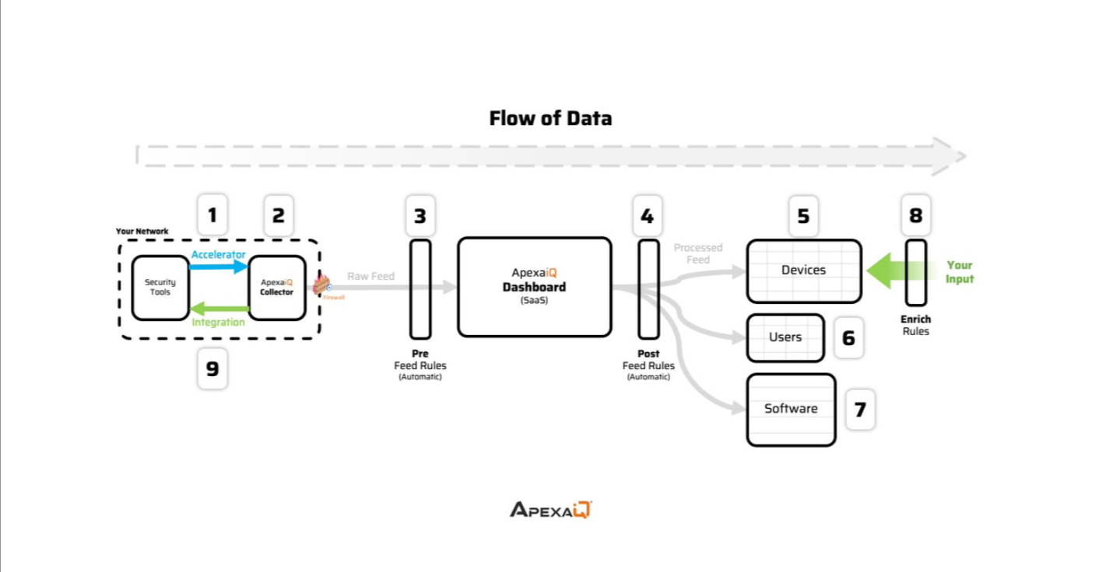
WEEK 2:
Overview of Week 2:
Week 2 transitioned from product architecture to backend engineering, focusing entirely on Python fundamentals and professional software development practices. The objective was to move beyond basic syntax memorization to understand how enterprise-grade code is structured, tested, and maintained. The module covered data processing, object-oriented design, API communication, and the standard engineering workflows required to build production-ready software.
Module 1: Python Language Mechanics & Data Handling
The foundation of the week focused on strict syntax rules and the core data structures used to store and manipulate information in Python.
- Variable Assignment & Core Data Types: Reviewed fundamental types including int (whole numbers), float (decimals), and string (text).
- Collection Types: Explored advanced data structures to handle grouped data:
  - Lists: Ordered, mutable collections.
  - Tuples: Ordered, immutable collections used for fixed data.
  - Dictionaries (dict): Key-value pairs optimized for fast data retrieval.
  - Sets: Unordered collections that strictly enforce unique values.
- List and Dictionary Comprehensions: Adopted pythonic shortcuts for building collections efficiently. Instead of writing multi-line loops, comprehensions allow developers to generate lists (e.g., [x*x for x in range(10)]) and dictionaries in a single, compact line of code, improving both readability and execution speed.
Module 2: Advanced Control Flow & Functional Programming
Proper routing of logic and efficient memory management are critical for backend applications handling large datasets.
- Conditional Logic & Loops: Implemented if/elif/else statements for decision-making pathways. Utilized for loops to iterate over sequences and while loops for continuous execution based on active conditions. Applied break (to terminate loops immediately) and continue (to skip to the next iteration) for precise control flow.
- Generators & Iterators: Studied the difference between standard iterators and generators. By using the yield keyword instead of return, generators produce items one at a time rather than loading an entire dataset into memory upfront. This is a critical technique for optimizing memory usage when processing large-scale data.
- Functions & Decorators:
  - Built reusable, single-purpose functions to minimize code duplication.
  - Managed flexible input parameters using *args (for positional arguments) and **kwargs (for named arguments).
  - Implemented Decorators (using the @ symbol) to wrap existing functions, allowing the program to append new behavior or logic to a function without permanently modifying its original source code.
Module 3: Object-Oriented Programming (OOP) & Reliability
To transition from writing simple scripts to designing complex applications, the training focused on organizing code around objects rather than linear instructions.
- The Four Pillars of OOP:
  - Abstraction: Hiding complex backend operations behind simple, user-facing interfaces.
  - Encapsulation: Bundling raw data and the specific logic required to manipulate that data into a single, secure unit (a class).
  - Inheritance: Enabling new classes to inherit and extend the attributes and behaviors of existing classes, reducing redundant code.
  - Polymorphism: Allowing different objects to process the same action or method in their own unique way.
- Exception Handling for System Stability: Addressed runtime reliability using try, except, and finally blocks. This structure isolates risky operations, catches specific runtime errors gracefully (preventing full system crashes), and ensures that necessary cleanup tasks execute regardless of whether the operation succeeded or failed.
Module 4: Environment Management & Code Quality Standards
Writing functional code is only half the requirement; code must also be readable, scalable, and safe for team collaboration.
- Package & Dependency Management:
  - Explored package organization using __init__.py files to structure related modules.
  - Differentiated between built-in packages (sys, os), third-party packages installed via pip (requests, pandas), and user-defined custom packages.
  - Implemented Virtual Environments (venv) to isolate project dependencies. This ensures that libraries installed for one project do not conflict with the system-wide environment or other concurrent projects, managed via requirements.txt.
- Professional Coding Standards (PEP 8):
  - Enforced strict naming conventions: snake_case for variables and functions, and PascalCase for classes.
  - Integrated comprehensive documentation via inline comments (#) for complex logic and Docstrings for formal structural definitions of classes and methods.
- Testing & Design Principles:
  - Covered the three standard testing tiers: Unit Testing (isolated component checks), Integration Testing (multi-component checks), and End-to-End Testing (full system flow).
  - Grounded all development in DRY (Don't Repeat Yourself) and SOLID principles to guarantee flexible and maintainable software architecture.
Module 5: API Integration & System Communication
Modern software relies on continuous communication between separate systems. The module detailed how APIs act as the standard contract for this data exchange.
- API Architectures: Reviewed common industry styles including REST, SOAP, and GraphQL, with a heavy emphasis on handling JSON payloads.
- HTTP Status Codes: Learned to diagnose system responses accurately:
  - 2xx: Success (e.g., 200 OK).
  - 4xx: Client-side errors (e.g., 404 Not Found).
  - 5xx: Server-side execution failures.
- CRUD Operations: Mapped the core database actions to standard HTTP methods: Create (POST), Read (GET), Update (PUT/PATCH), and Delete (DELETE).
- Security & Performance: Covered API authentication methods including standard API Keys, OAuth 2.0, and JWTs. Discussed performance optimization tactics such as rate limiting, caching, and payload compression, utilizing the Python requests library to execute these calls programmatically.
Module 6: Software Engineering Lifecycle & Architecture
The final phase of the week contextualized backend code within the broader lifecycle of enterprise software development.
- SDLC & Agile: Reviewed the Software Development Life Cycle (Plan, Design, Build, Test, Deploy, Maintain) and the Agile methodology, which prioritizes iterative development and frequent value delivery over massive, delayed releases.
- Version Control: Explored Git as the fundamental tool for tracking code modifications, enabling branching, safe rollbacks, and seamless team collaboration.
- System Architecture: Compared major structural blueprints, analyzing the trade-offs between Monolithic applications, Microservices, Layered (N-tier) systems, and Event-Driven architectures.
Key Takeaway
Mastering Python for backend engineering requires far more than understanding syntax; it demands strict adherence to professional habits. Clean naming conventions, rigorous testing, isolated virtual environments, and a deep understanding of API communications form the critical baseline required to write code that is not just functional, but highly maintainable and ready for production deployment in upcoming project phases.

WEEK 3:
Core JavaScript & Data Management
- JavaScript acts as the behavior layer of web development, adding dynamic interactivity alongside HTML (structure) and CSS (styling). It runs on the client-side within browsers and on the server-side via Node.js.
- Variables: Best practices dictate using const by default (especially for Arrays and Objects), let if a value needs to change, and avoiding the older var keyword unless supporting legacy browsers.
- Data Structures: Arrays are ordered lists for managing multiple items, utilizing built-in methods like .push() to add items and .map() for processing. Objects act as collections of key-value pairs to store related properties and methods.
Logic, Control Flow & Functions
- Control Flow: Program execution is directed using conditionals (if, else if, switch) and iteration tools such as for, for/in (for objects), and while loops.
- Functions: Functions are reusable blocks of code that take input parameters and return output values.
- Modern development relies on several function types, including Arrow functions for shorter syntax, IIFEs that run automatically, and Higher-Order functions that accept or return other functions.
Web Interactivity (DOM & Events)
- The DOM (Document Object Model): The DOM represents a webpage's HTML structure as a programmatic tree of nodes. JavaScript interacts with this tree to dynamically create elements, update text, and alter CSS styling.
- Event Handling: JavaScript "listens" for user-driven browser actions. Common events include onclick for button presses, onmouseover for mouse hovering, and onsubmit for form entries.
Asynchronous Logic & Advanced Concepts
- Handling Delays: For tasks that take time—such as reading files or making API requests—JavaScript relies on Callbacks (functions passed as arguments) and Promises (objects representing pending, fulfilled, or rejected operations).
- Async/Await: This modern syntax is built on top of Promises to make asynchronous tasks read cleanly like synchronous code, using try...catch blocks for straightforward error handling.
- Closures: A closure is a function that remembers and accesses variables from its outer scope, even after the outer function has finished running. This concept is crucial for maintaining data privacy and building encapsulated logic.

WEEK4: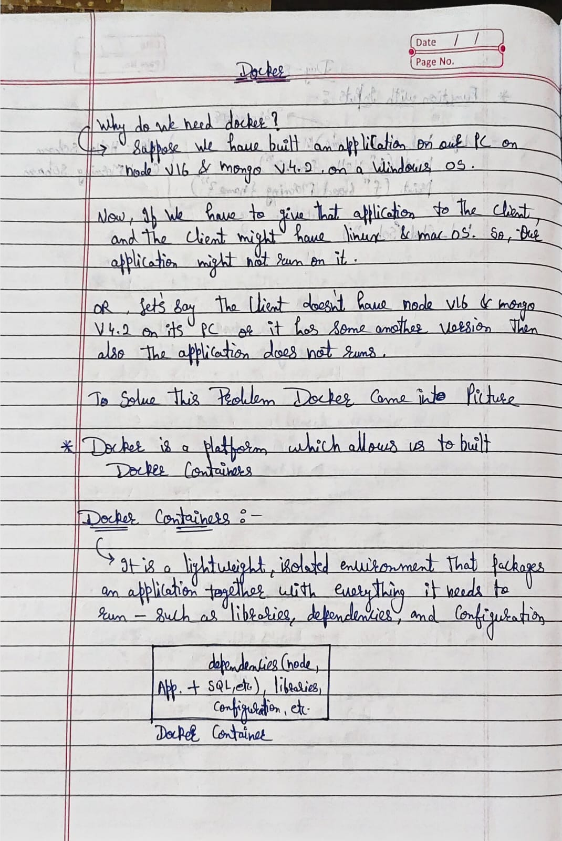: 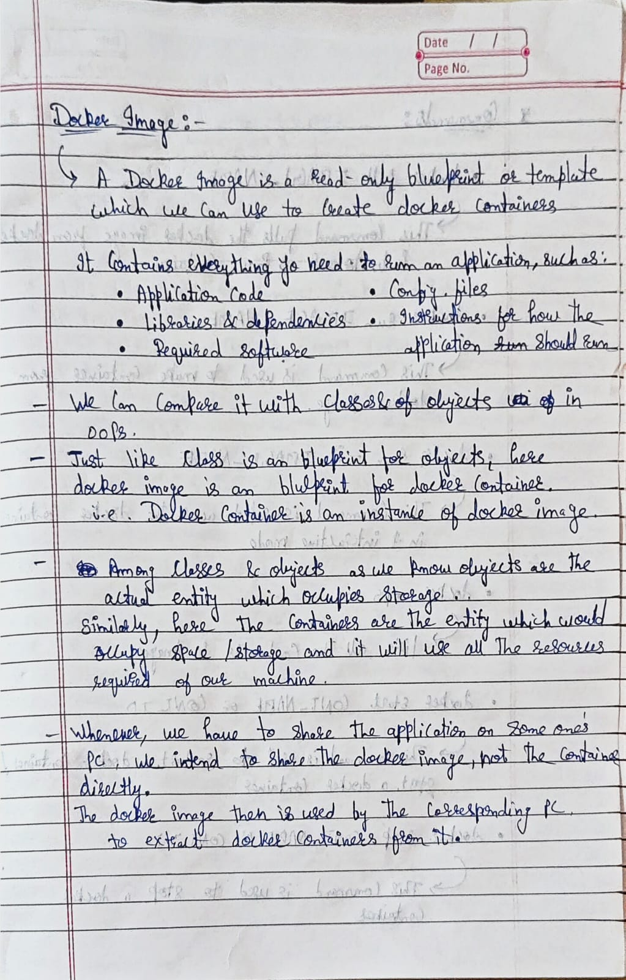
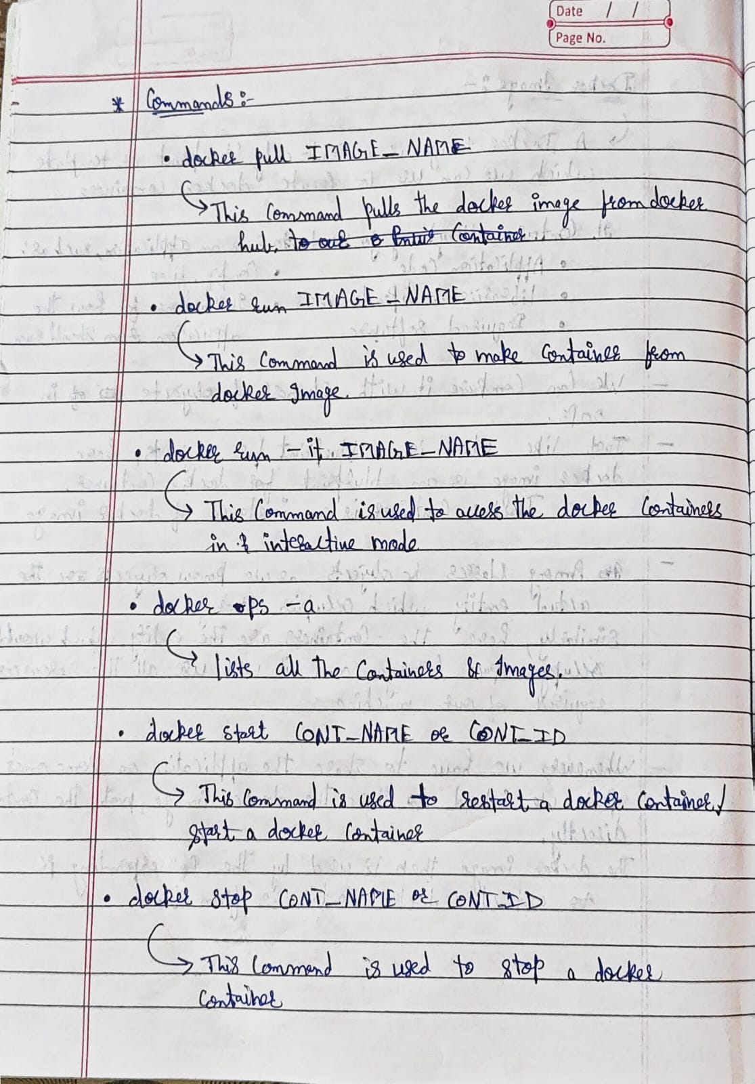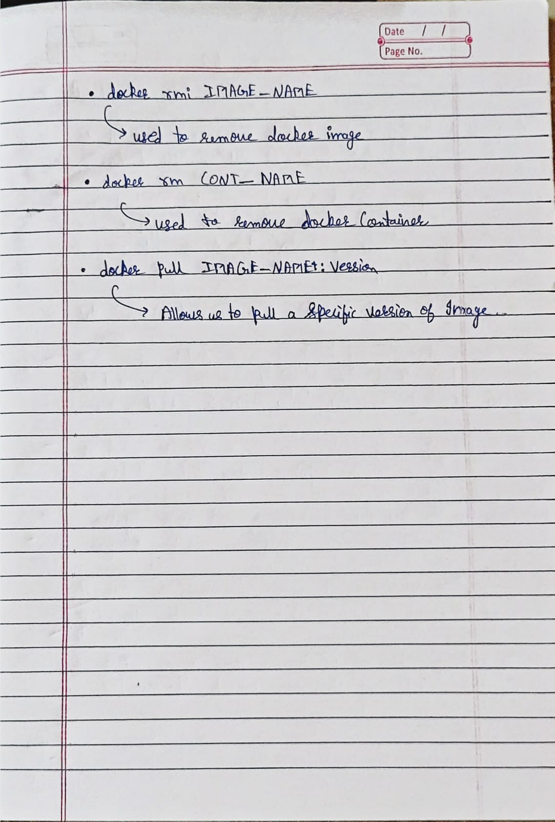
Introduction to DevOps:
- The Problem: Traditionally, software development had a "wall of confusion." Developers (Dev) would write code and pass it over to IT Operations (Ops) to deploy. If the code failed in the live environment, developers blamed the servers ("It works on my machine!"), and operations blamed the code. This resulted in slow releases, bugs, and team friction.
- The Solution: DevOps (Development + Operations) is not a single tool or a software program. It is a culture, a set of practices, and a philosophy that brings these two teams together to collaborate continuously.
- The Goal: The main objective of DevOps is to shorten the software development lifecycle, allowing companies to deliver features, fixes, and updates frequently, quickly, and reliably.
Core Principles of DevOps
- Automation: Anything that can be automated should be. This includes testing code, building the software, and configuring the servers. Automation removes human error and drastically speeds up the process.
- Collaboration: Breaking down the "silos" between teams so developers, system administrators, and quality assurance (QA) testers share responsibility for the final product.
- Continuous Improvement: Using feedback from the live software to immediately plan the next set of updates or fixes.
The CI/CD Pipeline (The Engine of DevOps)
The most important technical concept in DevOps is CI/CD, which automates the journey of code from a developer's laptop to the live user environment.
- Continuous Integration (CI):
  - As multiple developers work on a project, they constantly merge their code changes into a central repository (like GitHub).
  - Every time code is merged, an automated system instantly builds the application and runs tests to ensure the new code didn’t break anything.
- Continuous Delivery (CD):
  - Once the code passes all tests, it is automatically prepared for a production release. The code is ready to be deployed at the push of a single button.
- Continuous Deployment (CD):
  - Taking delivery one step further, Continuous Deployment entirely automates the release. The moment code passes testing, it goes live to customers automatically without any manual approval.
Essential DevOps Practices & Tools
- Infrastructure as Code (IaC): Instead of manually configuring servers, databases, and networks by clicking through menus, DevOps engineers write code to set up the infrastructure. This means you can spin up an exact replica of a server environment in seconds.
- Containerization: Packaging an application and its dependencies together so it runs uniformly on any system, eliminating the "it works on my machine" problem. (Common tool: Docker)
- Orchestration: Managing, scaling, and maintaining thousands of containers automatically. If a container crashes, the orchestrator replaces it immediately. (Common tool: Kubernetes)
- Continuous Monitoring: Automatically tracking the health, performance, and security of the application in real-time. If the system slows down or crashes, automated alerts notify the team immediately)
What is Linux?
Think of Linux as an operating system just like Windows or macOS. Its job is to make a computer run. However, unlike Windows, Linux is mostly invisible to everyday users because it runs behind the scenes. Almost every website you visit, most mobile phones (Android), and the world's biggest servers are powered by Linux.
Why the Tech Industry Prefers It
- It is 100% Free: Companies like Google and Amazon use thousands of computers. With Linux, they don’t have to pay for expensive software licenses for each one.
- It is Super Fast and Light: Most Linux servers do not use a mouse, icons, or a desktop screen. They run entirely on a text screen. Without drawing graphics, the computer can focus all its power on running programs fast.
- It is Open Source: This means the code that makes Linux work is public. Anyone can see it, fix bugs, or change it to fit their exact needs.
- Easy to Automate: Because you control it by typing commands, it is very easy to write scripts that tell the computer to do repetitive tasks on its own.
Key Features
- Never Crashes: Linux is famous for being incredibly stable. A Linux computer can often run for years without ever needing to be restarted, which is perfect for websites that must stay online 24/7.
- High Security: Linux is very strict about rules. A normal user cannot make big changes to the computer without typing a special admin password. This makes it very hard for viruses to take over.
- Built-in App Store: Instead of going to a website and downloading an installer, Linux has a safe, built-in system. You type one command, and it securely downloads and installs the software you need.
Basic Linux Command:
- pwd (Print Working Directory): Tells you exactly which folder you are currently inside.
- ls (List): Shows all the files and folders that are in your current location.
- cd (Change Directory): Opens and moves you into a different folder (e.g., cd Documents). Typing cd .. takes you back out to the previous folder.
- mkdir (Make Directory): Creates a brand new, empty folder.
- rmdir: Removes an empty Directory.
- touch: Creates a new, completely blank file (e.g., touch notes.txt).
- cat: Opens a file and reads the text inside it directly onto your screen.
- rm (Remove): Deletes a file permanently.

